Punim seminarik nga lënda e statistikës

Përshkrim i punimit: Ky punim paraqet disa të dhëna statistikore në lidhje me performancën e veturave. Dataseti i përdorur në këtë punim (vetura.csv1) përmban 9 karakteristika **(**"MPG”, "Cylinders", "Displacement", "Horsepower", "Weight", "Acceleration", "Model.Year", “Origin”, "Make.and.Model")dhe 398 rreshta.

Interpretimi i të dhënave

Të dhëna bazike(statistikat e karakteristikave)

MPG Cylinders Displacement

Min. : 9.00 Min. :3.000 Min. : 68.0

1st Qu.:17.50 1st Qu.:4.000 1st Qu.:104.2

Median :23.00 Median :4.000 Median :148.5

Mean :23.51 Mean :5.455 Mean :193.4

3rd Qu.:29.00 3rd Qu.:8.000 3rd Qu.:262.0

Max. :46.60 Max. :8.000 Max. :455.0

Horsepower Weight Acceleration

Min. : 46.0 Min. :1613 Min. : 8.00

1st Qu.: 75.0 1st Qu.:2224 1st Qu.:13.82

Median : 92.0 Median :2804 Median :15.50

Mean :104.2 Mean :2970 Mean :15.57

3rd Qu.:125.0 3rd Qu.:3608 3rd Qu.:17.18

Max. :230.0 Max. :5140 Max. :24.80

|  |
| --- |
| Model.Year Origin  Min. :70.00 Min. :1.000  1st Qu.:73.00 1st Qu.:1.000  Median :76.00 Median :1.000  Mean :76.01 Mean :1.573  3rd Qu.:79.00 3rd Qu.:2.000  Max. :82.00 Max. :3.000 |
| |  | | --- | |  | |

[1] "MPG"

[1] "Varianca 61.0896107742744"

[1] "Devijimi standard 7.81598431256578"

Frekuenca F.Rel F.Kum F.Kum.Rel

[9,11) 3 0.007537688 3 0.007537688

[11,13) 10 0.025125628 13 0.032663317

[13,15) 40 0.100502513 53 0.133165829

[15,17) 39 0.097989950 92 0.231155779

[17,19) 39 0.097989950 131 0.329145729

[19,21) 40 0.100502513 171 0.429648241

[21,23) 26 0.065326633 197 0.494974874

[23,25) 32 0.080402010 229 0.575376884

[25,27) 36 0.090452261 265 0.665829146

[27,29) 28 0.070351759 293 0.736180905

[29,31) 24 0.060301508 317 0.796482412

[31,33) 27 0.067839196 344 0.864321608

[33,35) 18 0.045226131 362 0.909547739

[35,37) 13 0.032663317 375 0.942211055

[37,39) 11 0.027638191 386 0.969849246

[39,41) 5 0.012562814 391 0.982412060

[41,43) 1 0.002512563 392 0.984924623

[43,45) 5 0.012562814 397 0.997487437

[45,47) 1 0.002512563 398 1.000000000

1. Regresione lineare te njefishta
   1. Regresioni linear i njefisht ndermjet 'Horsepower' dhe 'Displacement' ('kuaj fuqi' dhe 'vëllimi i cilindrit të motorit'):

Residuals:

Min 1Q Median 3Q Max

-50.822 -10.803 -0.848 9.018 64.751

Coefficients:

Estimate Std. Error t value Pr(>|t|)

(Intercept) 40.370038 1.817158 22.22 <2e-16 ***

Displacement 0.329807 0.008272 39.87 <2e-16 ***

---

Signif. codes: 0 ‘***’ 0.001 ‘**’ 0.01 ‘*’ 0.05 ‘.’ 0.1 ‘ ’ 1

Residual standard error: 17.19 on 396 degrees of freedom

Multiple R-squared: 0.8006, Adjusted R-squared: 0.8001

F-statistic: 1590 on 1 and 396 DF, p-value: < 2.2e-16

Intervali i konfidences:

2.5 % 97.5 %

(Intercept) 36.797556 43.9425206

Displacement 0.313545 0.3460697

Funksioni i vijes se regresionit

y= 40.37 + 0.3298 *x

Scatter plot

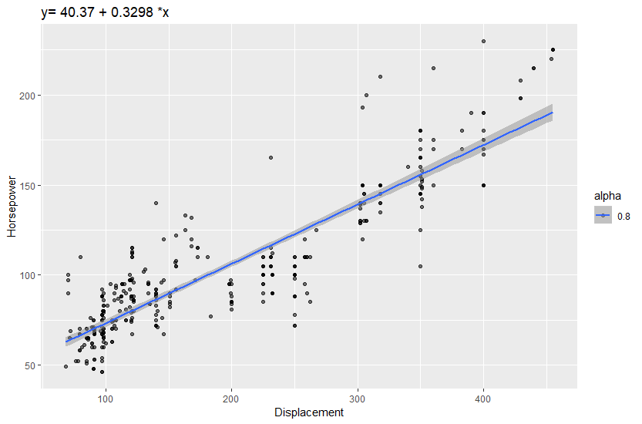

Q-Q plot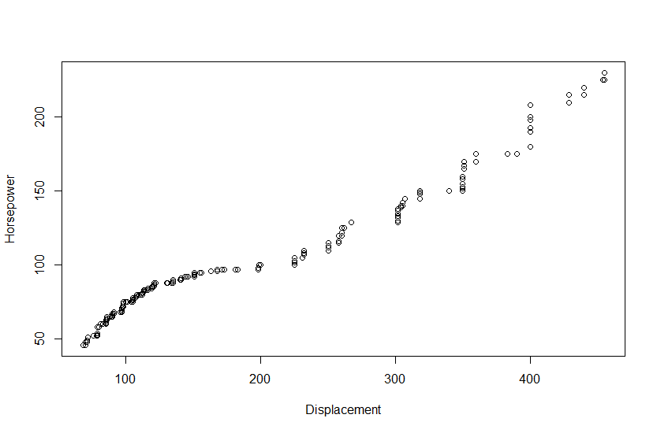

* 1. Regresion linear i njefisht ndermjet 'Displacement' dhe 'Cylinders' ('vëllimi i cilindrit të motorit'dhe 'Cilindri')

Residuals:

Min 1Q Median 3Q Max

-81.757 -23.394 -0.201 17.701 113.243

Coefficients:

Estimate Std. Error t value Pr(>|t|)

(Intercept) -124.4688 5.4565 -22.81 <2e-16 ***

Cylinders 58.2783 0.9551 61.02 <2e-16 ***

---

Signif. codes: 0 ‘***’ 0.001 ‘**’ 0.01 ‘*’ 0.05 ‘.’ 0.1 ‘ ’ 1

Residual standard error: 32.37 on 396 degrees of freedom

Multiple R-squared: 0.9039, Adjusted R-squared: 0.9036

F-statistic: 3723 on 1 and 396 DF, p-value: < 2.2e-16

Intervali i konfidences.

2.5 % 97.5 %

(Intercept) -135.19613 -113.74156

Cylinders 56.40063 60.15589

Funksioni i vijes se regresionit

y= -124.4688 + 58.2783 *x

Scatter plot

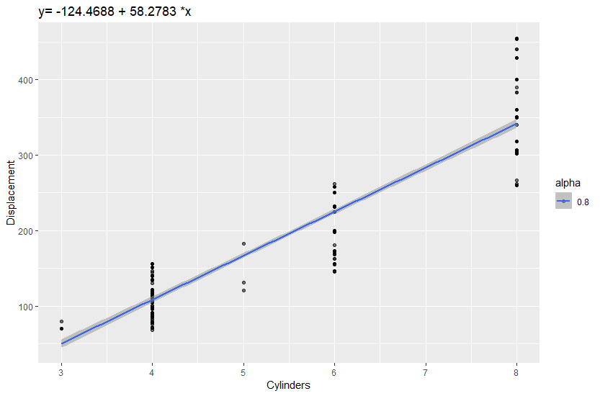

Q-Q plot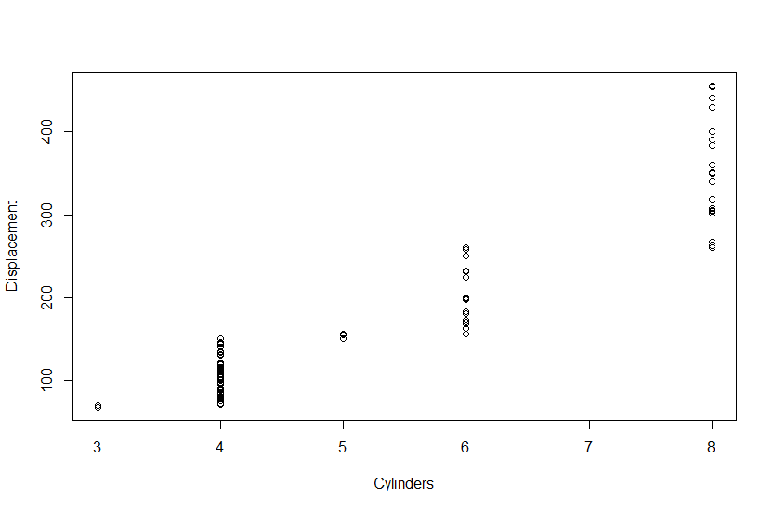

1. Regresione lineare te shumefishta
   1. Regresion linear i shumefishte ndermjet 'MPG' dhe 'Horsepower+Weight' ('MPG' dhe 'kuaj-fuqi+pesha')

Residuals:

Min 1Q Median 3Q Max

-11.1013 -2.7475 -0.3437 2.2120 16.2190

Coefficients:

Estimate Std. Error t value Pr(>|t|)

(Intercept) 45.731271 0.789284 57.94 < 2e-16 ***

Horsepower -0.047941 0.010995 -4.36 1.66e-05 ***

Weight -0.005798 0.000499 -11.62 < 2e-16 ***

---

Signif. codes: 0 ‘***’ 0.001 ‘**’ 0.01 ‘*’ 0.05 ‘.’ 0.1 ‘ ’ 1

Residual standard error: 4.249 on 395 degrees of freedom

Multiple R-squared: 0.7059, Adjusted R-squared: 0.7045

F-statistic: 474.1 on 2 and 395 DF, p-value: < 2.2e-16

Intervali i konfidences.

2.5 % 97.5 %

(Intercept) 44.179549084 47.282992519

Horsepower -0.069557201 -0.026325356

Weight -0.006779201 -0.004817104

Funksioni i vijes se regresionit

y= 45.7313 + -0.0479 *x1 + -0.0058 *x2

* 1. Regresion linear i shumefishte ndermjet 'Horsepower' dhe 'Cylinders+Weight+Displacement' ('MPG' dhe 'cilindri+pesha+vëllimi i cilindrit të motorit')

Residuals:

Min 1Q Median 3Q Max

-52.238 -10.361 -1.219 8.872 61.823

Coefficients:

Estimate Std. Error t value Pr(>|t|)

(Intercept) 32.504230 5.800700 5.604 3.95e-08 ***

Cylinders -3.223225 1.610602 -2.001 0.046050 *

Weight 0.010484 0.002784 3.766 0.000191 ***

Displacement 0.300373 0.032377 9.277 < 2e-16 ***

---

Signif. codes: 0 ‘***’ 0.001 ‘**’ 0.01 ‘*’ 0.05 ‘.’ 0.1 ‘ ’ 1

Residual standard error: 16.87 on 394 degrees of freedom

Multiple R-squared: 0.8089, Adjusted R-squared: 0.8074

F-statistic: 555.7 on 3 and 394 DF, p-value: < 2.2e-16

Intervali i konfidences.

2.5 % 97.5 %

(Intercept) 21.100036239 43.90842445

Cylinders -6.389673435 -0.05677625

Weight 0.005011079 0.01595643

Displacement 0.236719649 0.36402570

Funksioni i vijes se regresionit

y= 32.5042 + -3.2232 *x1 + 0.0105 *x2 + 0.3004 *x3

* 1. Regresion linear i shumefishte ndermjet 'MPG' dhe 'Cylinders + Weight + Displacement +Horsepower+Acceleration' ('MPG' dhe 'cilindri+pesha+vëllimi i cilindrit të motorit')

Residuals:

Min 1Q Median 3Q Max

-11.6467 -2.8712 -0.3295 2.2861 16.3191

Coefficients:

Estimate Std. Error t value Pr(>|t|)

(Intercept) 46.9003282 2.6542281 17.670 < 2e-16 ***

Cylinders -0.3959586 0.4090026 -0.968 0.3336

Weight -0.0051204 0.0008129 -6.299 8.04e-10 ***

Displacement -0.0001124 0.0090680 -0.012 0.9901

Horsepower -0.0487599 0.0163817 -2.976 0.0031 **

Acceleration -0.0587901 0.1245652 -0.472 0.6372

---

Signif. codes: 0 ‘***’ 0.001 ‘**’ 0.01 ‘*’ 0.05 ‘.’ 0.1 ‘ ’ 1

Residual standard error: 4.255 on 392 degrees of freedom

Multiple R-squared: 0.7073, Adjusted R-squared: 0.7036

F-statistic: 189.5 on 5 and 392 DF, p-value: < 2.2e-16

Intervali i konfidences.

2.5 % 97.5 %

(Intercept) 41.68202527 52.118631047

Cylinders -1.20007169 0.408154509

Weight -0.00671857 -0.003522323

Displacement -0.01794032 0.017715500

Horsepower -0.08096687 -0.016553022

Acceleration -0.30368942 0.186109264

Funksioni i vijes se regresionit

y= 46.9003 + -0.396 *x1 + -0.0051 *x2 + -1e-04 *x3 -0.0488 *x4 -0.0588 *x5